Modelling of the McKibben artificial muscle: A review - Bertrand Tondu
- Use virtual work to define a relationship between the radial and axial strains and internal pressure and applied force:
$$2πrlP\left(δr\right)+πr^{2}P\left(δl\right)+F\left(δl\right)=0$$This is more general than McKibben muscles, it’s literally just a cylinder that changes shape (but remains cylindrical) under axial load
We define a strain function: $f\left(ε\right)=\frac{r}{r_{0}}, ε=\frac{l_{0}-l}{l_{0}}$, which when ‘differentiated’ yields
$$δr=-\frac{r_{0}}{l_{0}}\dot{f}\left(ε\right)δl \\ Combining this with the previous equation we get: \\ F\left(ε\right)=\left(πr_{0}^{2}\right)P\left[2\left(1-ε\right)f\left(ε\right)\dot{f}\left(ε\right)-f^{2}\left(ε\right)\right]$$
- Idealized McKibben muscle as a mesh of jointed pantographs:
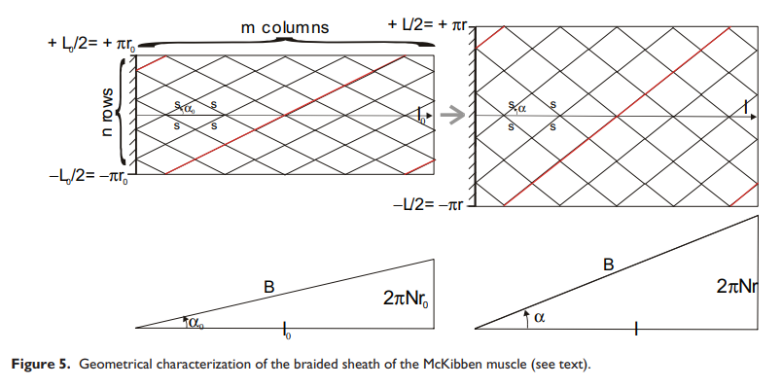
Mentions that they later justify s remains constant.
Geometric relationships are easy:
$$\frac{r}{r_{0}}=\frac{\sin{α}}{\sin{α_{0}}}, \frac{l}{l_{0}}=\frac{\cos{α}}{\cos{α_{0}}} \\ From these we can derive: \\ f\left(ε\right)=\frac{r}{r_{0}}=\frac{1}{\sin{α_{0}}}\sqrt{1-\cos^{2}{α_{0}}{\left(1-ε\right)}^{2}} where ε=\frac{l_{0}-l}{l_{0}} \\ Quick proof:$$
$$ε=1-\frac{\cos{α}}{\cos{α_{0}}}→{\left(1-ε\right)}^{2}=\frac{\cos^{2}{α}}{\cos^{2}{α_{0}}} \\ →\sqrt{1-\cos^{2}{α_{0}}{\left(1-ε\right)}^{2}}=\sqrt{1-\cos^{2}{α}}=\sin\left(α\right) \\ →\frac{1}{\sin{α_{0}}}\sqrt{1-\cos^{2}{α_{0}}{\left(1-ε\right)}^{2}}=\frac{\sin{α}}{\sin{α_{0}}}=f\left(ε\right) \\ They then give$$an expression for the strain-force relationship for an idealized McKibben muscle.
- Role of braided mesh
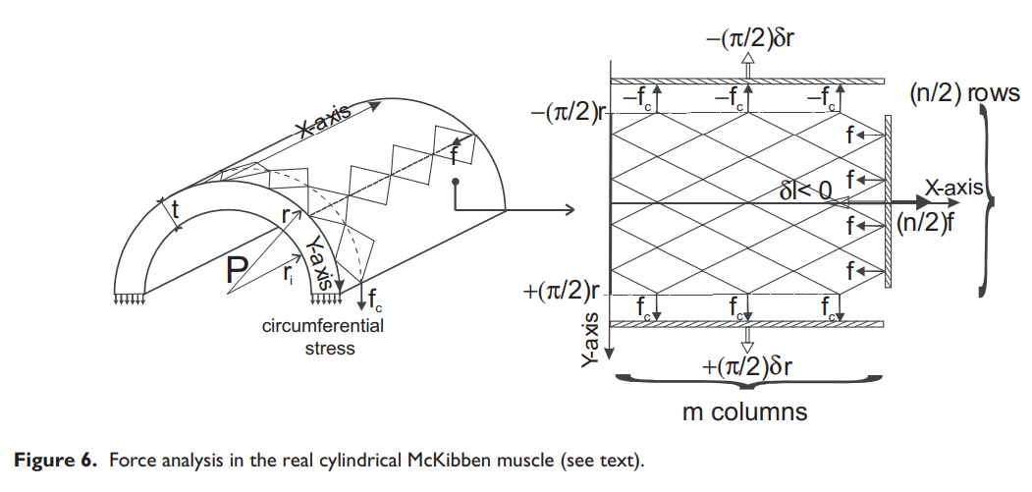
dimensions can be written:
$$l=2ms\cos{α}, 2πr=2ns\sin{α}$$

For each row of the McKibben network, we define the contraction force produced in the axial direction as $f$ and the circumferential force as $f_{c}$. We use virtual work to obtain a relationship:
$$2mf_{c}\left(\frac{π}{2}\right)δr+\frac{n}{2}fδl=0→f=\frac{\cos{α}}{\sin{α}}f_{c}$$
Force*displacement in radial direction, force*displacement in axial direction
2m because the muscle contracts on 2 sides (work done with force fc on 2 sides). n/2 b/c there’s only 1 side with axial displacement and there’s only n/2 rows.
quick proof of the above:
$$2\left(\frac{l}{2s\cos{α}}\right)f_{c}\left(\frac{π}{2}\right)δr+\frac{1}{2}\left(\frac{πr}{s\sin{α}}\right)fδl=0 \\ →\frac{πlδr}{2s\cos{α}}f_{c}+\frac{πrδl}{2s\sin{α}}f=0 \\ →\frac{lδr}{\cos{α}}f_{c}+\frac{rδl}{\sin{α}}f=0 \\ →f=-\frac{lδr}{rδl}\frac{\sin{α}}{\cos{α}}f_{c}$$
They say this reduces to $f=\frac{\cos{α}}{\sin{α}}f_{c}$, but I fail to see how that’s the case. I think they make a mistake here. Using virtual work for a cylinder (no mesh) with no external force we get a relationship:

$$2πrlP\left(δr\right)+πr^{2}P\left(δl\right)+F\left(δl\right)=0 \\ →2l\left(δr\right)=-r\left(δl\right) \\ →1=-\frac{2lδr}{rδl} \\ But this then gives us: \\ f=\frac{1}{2}\frac{\sin{α}}{\cos{α}}f_{c}$$They use a relationship for the total circumferential force: $f_{c}m=r_{i}lP$, seems to come from Barlow’s formula.
This then reduces to an axial force:
$$F_{cyl braid}=2nf=2πr_{i}r\frac{\cos^{2}{α}}{\sin^{2}{α}}P$$

They then introduce one more term for pressure pushing out against the end of the muscle to get the net contractile force of the cylinder:
$$F_{real cyl}=\left(2πr_{i}r\frac{\cos^{2}{α}}{\sin^{2}{α}}-πr_{i}^{2}\right)P$$

- Role of rubber tube
We define strain in a cylindrical tube of rubber with non-negligible thickness as:
$$λ_{1}=\frac{r_{i}}{r_{i0}}, λ_{2}=\frac{l}{l_{0}}, λ_{3}=\frac{t}{t_{0}}$$“According to statistical theory, corresponding stresses”:
$$\left\{\begin{matrix}σ_{1}-σ_{3}=G\left(λ_{1}^{2}-λ_{3}^{2}\right) \\ σ_{2}-σ_{3}=G\left(λ_{2}^{2}-λ_{3}^{2}\right)\end{matrix}\right. \\ Using an assumption for thin-walled tube we can say σ_{3}=0$$:
$$σ_{1}=G\left(λ_{1}^{2}-\frac{1}{λ_{1}^{2}λ_{2}^{2}}\right), σ_{2}=G\left(λ_{2}^{2}-\frac{1}{λ_{1}^{2}λ_{2}^{2}}\right)$$Circumferential stress given by: $σ_{1}=\frac{Pr_{i}}{t}$
Add new variables: $λ=\frac{r}{r_{0}}, h_{0}=\frac{t_{0}}{r_{0}}$
We use the previously-derived contraction function as a constraint function:
Constraint: $f\left(ε\right)=\frac{r}{r_{0}}=\frac{1}{\sin{α_{0}}}\sqrt{1-\cos^{2}{α_{0}}{\left(1-ε\right)}^{2}} where ε=\frac{l_{0}-l}{l_{0}}$
Stresses: $σ_{1}=G\left(λ_{1}^{2}-\frac{1}{λ_{1}^{2}λ_{2}^{2}}\right)=\frac{Pr_{i}}{t}, σ_{2}=G\left(λ_{2}^{2}-\frac{1}{λ_{1}^{2}λ_{2}^{2}}\right)$
They get to here somehow, which can relate the pressure to the expansion ratio $λ$:
$$\frac{P}{G}\frac{1-h_{0}}{h_{0}}=\frac{1}{λ_{2}}\left(1-\frac{1}{λ_{1}^{4}λ_{2}}\right) with \left\{\begin{matrix}λ_{2}=\frac{1}{\cos{α_{0}}}\sqrt{1-\sin^{2}{α_{0}}λ^{2}} \\ λ_{1}=\frac{λ}{2\left(1-h_{0}\right)}\left(1+\sqrt{1-\frac{4\left(1-h_{0}\right)h_{0}}{λ^{2}λ_{2}}}\right)\end{matrix}\right.$$
- Tip effects
I’m skimming this as it seems prudent to ignore tip effects for now. TLDR, they split the muscle into 3 sections: tip, middle, and end. They treat the tip and end as conical and do the same virtual work approach for them.
- Elastic force and the question of the McKibben muscle as a fibre-reinforced rubber tube
- Static friction and muscle hysteresis
Reconsidering the McKibben muscle: Energetics, operating fluid, and bladder material
Looks at efficiency from the perspective of energy
Models volume as a function of contraction strain and braid angle
A mechanical model for McKibben pneumatic artificial muscles based on limiting chain extensibility and 3D application of the network alteration theories
Uses continuum elasticity principles, so promising to combine with energy approach
most researchers use a moony-rivlin strain energy function, but they use a Gent model.

NASA Technical Note NASA TN D-3466
A linearized energy approach for static modeling of inflatable beams. It shows some examples at the bottom that I’ll write down questions for here.
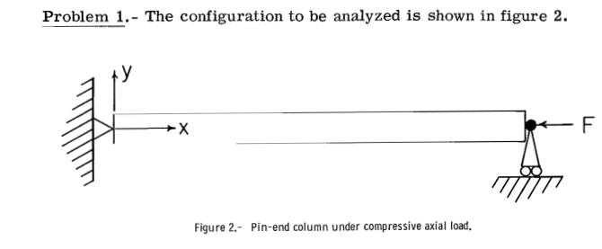

- We develop an equation for the axial force on the beam cross-section $N=P-F$ where P is the pressure force ($P=2πr$). We then plug into the following:
$${\left(NU_{2}^{'}\right)}^{'}+V_{2}^{'}-Pω_{3}^{'}+q_{2}=0 \\ →N^{'}U_{2}^{'}+NU_{2}^{''}+V_{2}^{'}-Pω_{3}^{'}=0 \\ →\left(P-F\right)U_{2}^{''}+V_{2}^{'}-Pω_{3}^{'}=0$$This equation apparently simplifies to: $\left(P+Gπrt-F\right)U_{2}^{''}-\left(P+Gπrt\right)ω_{3}^{'}=0$, which implies: $V_{2}^{'}=Gπrt\left(U_{2}^{''}-ω_{3}^{'}\right)$. How did we get that?
From this we can deduce (based on $Gπrt$ being independent of $x$):
$$V_{2}=Gπrt\left(U_{2}^{'}-ω_{3}\right)+C$$
- Similarly, the very next equation:
$$M_{3}^{'}+V_{2}+P\left(U_{2}^{'}-ω_{3}\right)+T_{3}=0 \\ →M_{3}^{'}+\left[Gπrt\left(U_{2}^{'}-ω_{3}\right)+C\right]+P\left(U_{2}^{'}-ω_{3}\right)=0 \\ →M_{3}^{'}+\left(Gπrt+P\right)\left(U_{2}^{'}-ω_{3}\right)=0$$Reduces to:
$$Eπr^{3}tω_{3}^{''}-\left(P+Gπrt\right)\left(U_{2}^{'}-ω_{3}\right)+C=0 \\ This implies that C=0$$ and $M_{3}^{'}=-Eπr^{3}tω_{3}^{''}$, where did the latter come from?
- Equation 27
$$ω_{3}=B_{1}\sin{βx}+B_{2}\cos{βx}+\frac{C}{F} \\ ω^{'}\left(0\right)=βB_{1}=0→B_{1}=0 \\ ω^{'}\left(L\right)=-βB_{2}\sin{βL}=0→βL=nπ, n=1,2,… \\ They only consider the βL=π$$ solution, neglecting the other solutions. Does superposition not make all solutions necessary? My guess is this is connected to $F_{cr}$ in the next step, in which case, why does solving for force that makes $βL=π$ yield critical force?
My understanding is that under pure compression like this beam is placed, we expect only axial deflection ($B_{1}=B_{2}=0$). In order for that to not necessarily be true, we need $βL=nπ$ and $βL=π$ yields the smallest value of $F$.

Theoretical and experimental analyses of beam-like inflatables
Building an FEM for inflatable beams using a “geometrically nonlinear large displacement large rotation corotational framework”.

Notes
- Loris Fichera at RBE knows a lot about Cosserat rod modeling. Has anyone done this with McKibben muscles?
- Can I decouple bending and axial response? The mesh under bending doesn’t seem to do much, just constrains axial deformation to radial deformation. If we can use a standard axial McKibben model to get axial forces and a bending inflatable beam model to get bending forces we can basically decouple them
- Cosserat rods, there’s a python script, built off of elastica type deformations
- Mckibben or inflatable beam in cosserat rod theory?

